# CS 255 System Design Document Template

## UML Diagrams

### UML Use Case Diagram

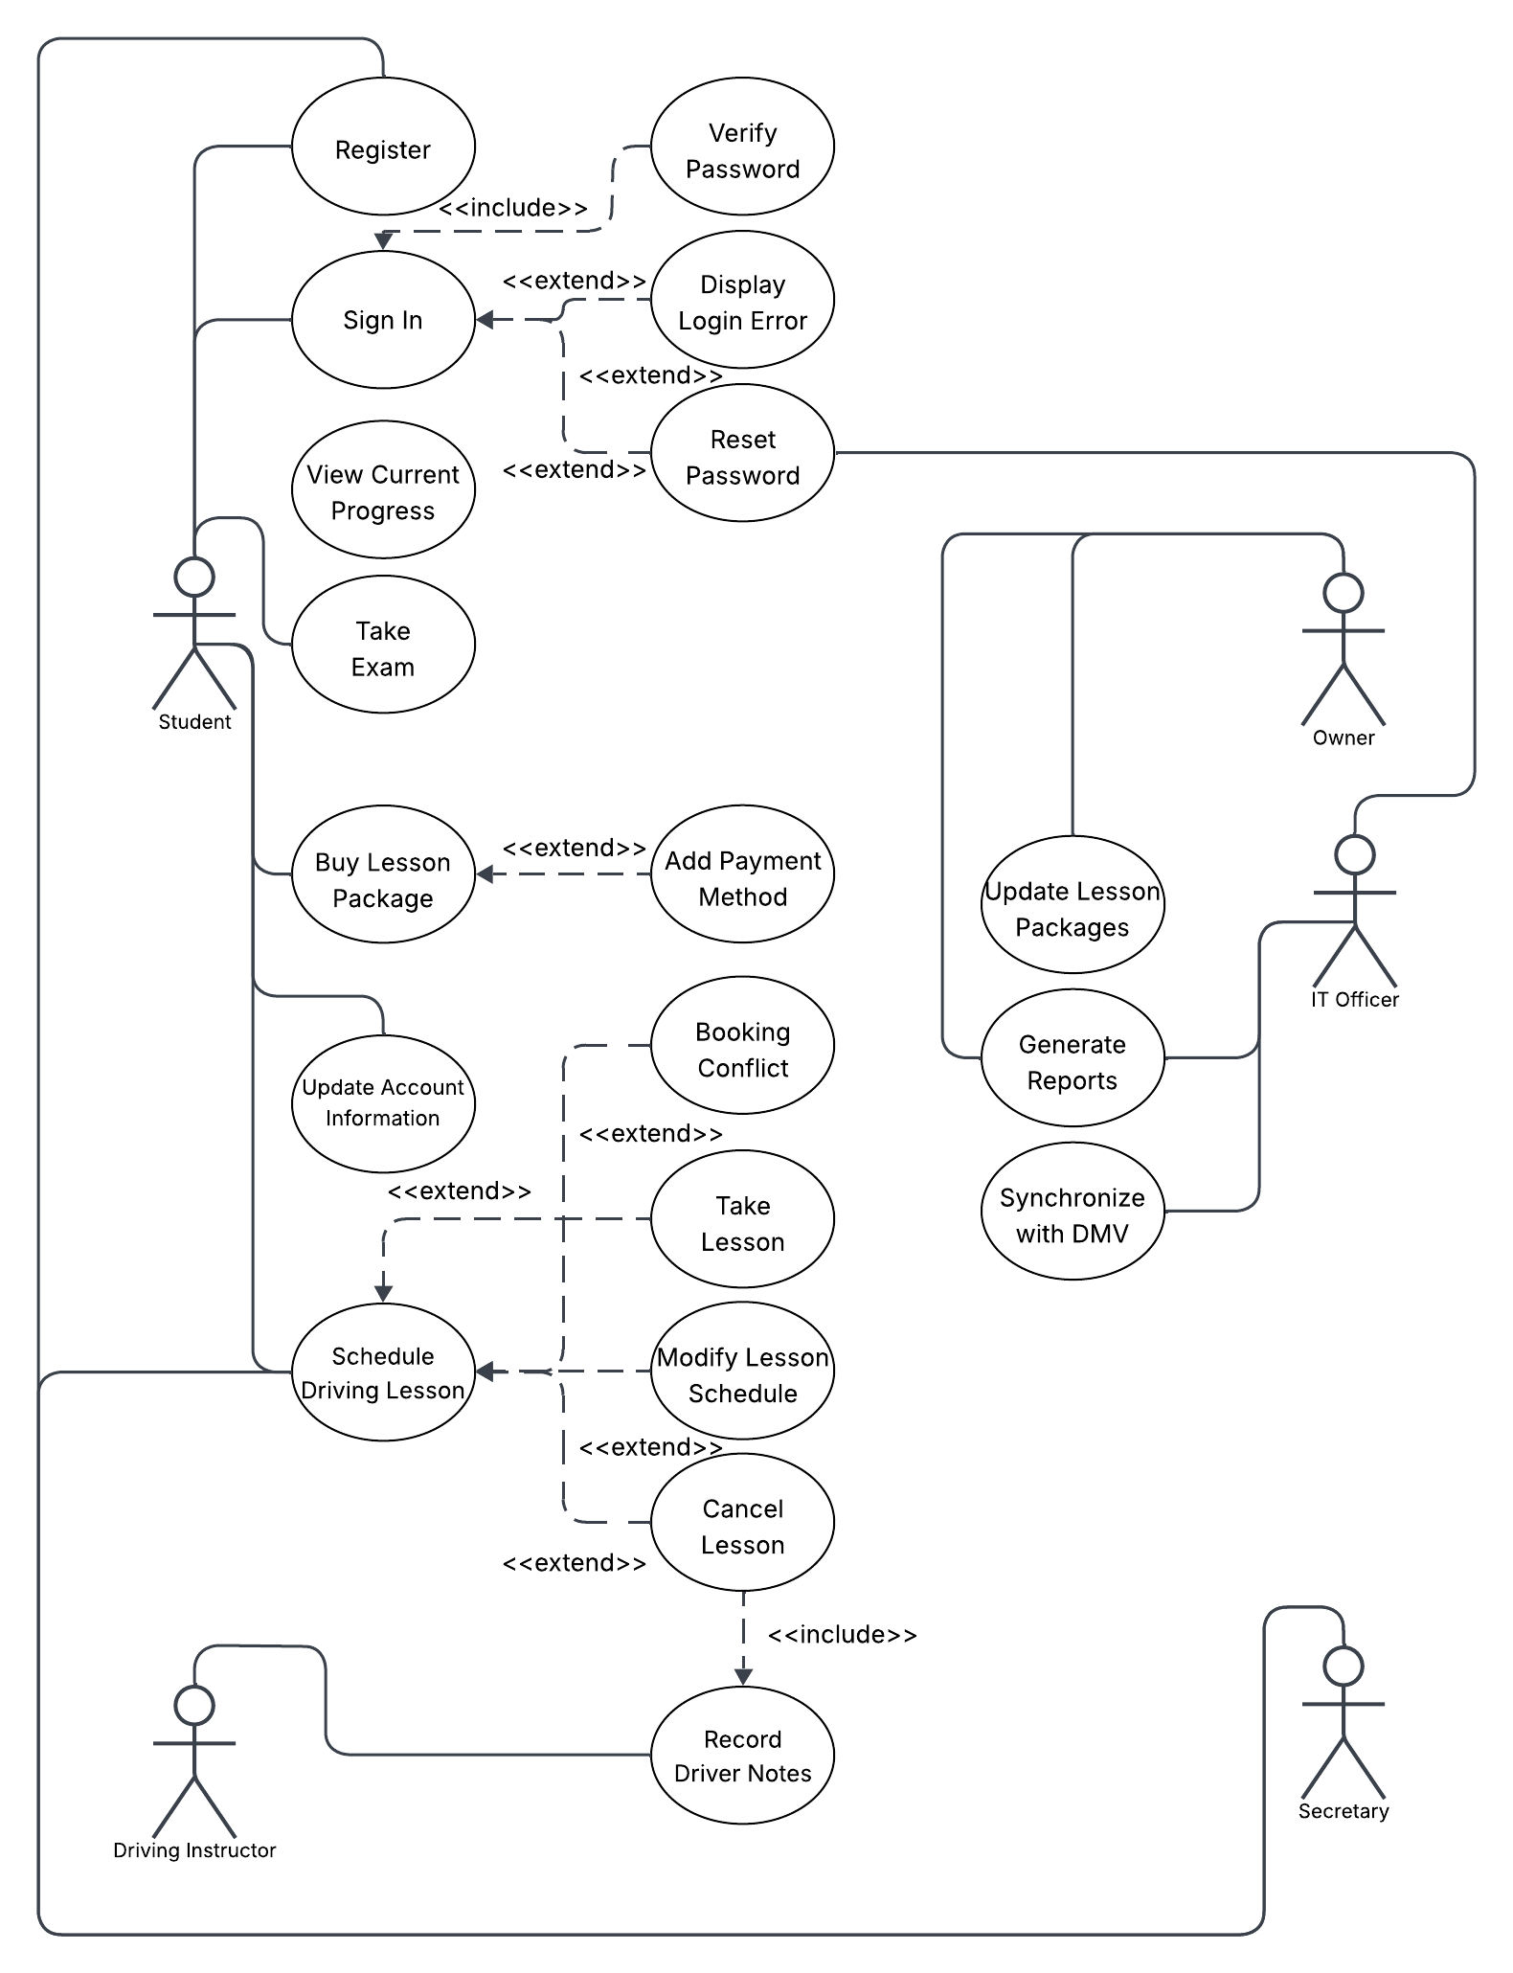

### UML Activity Diagrams

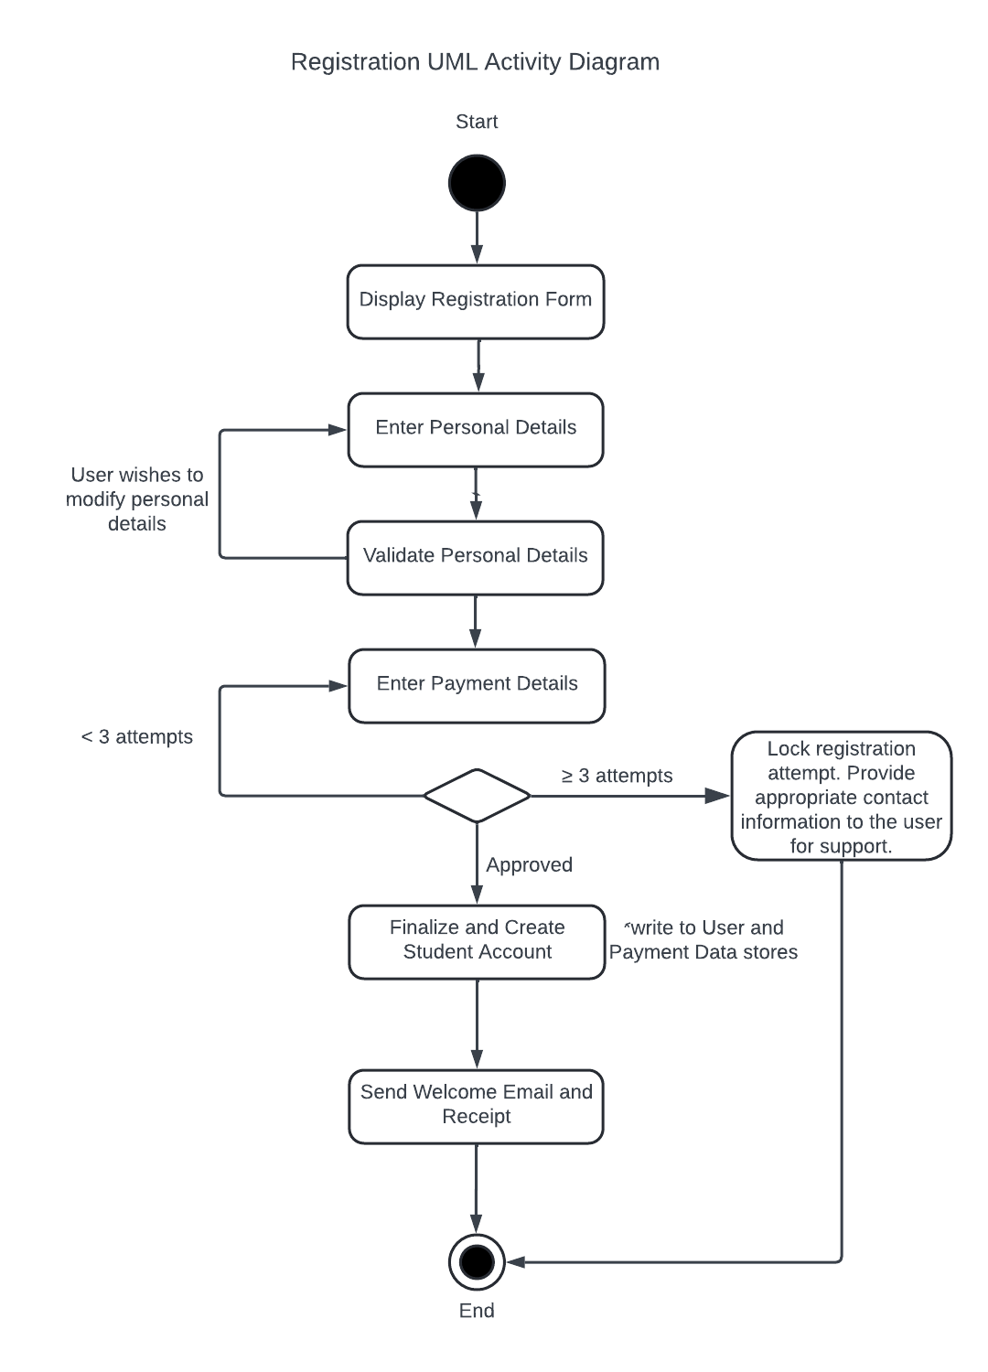

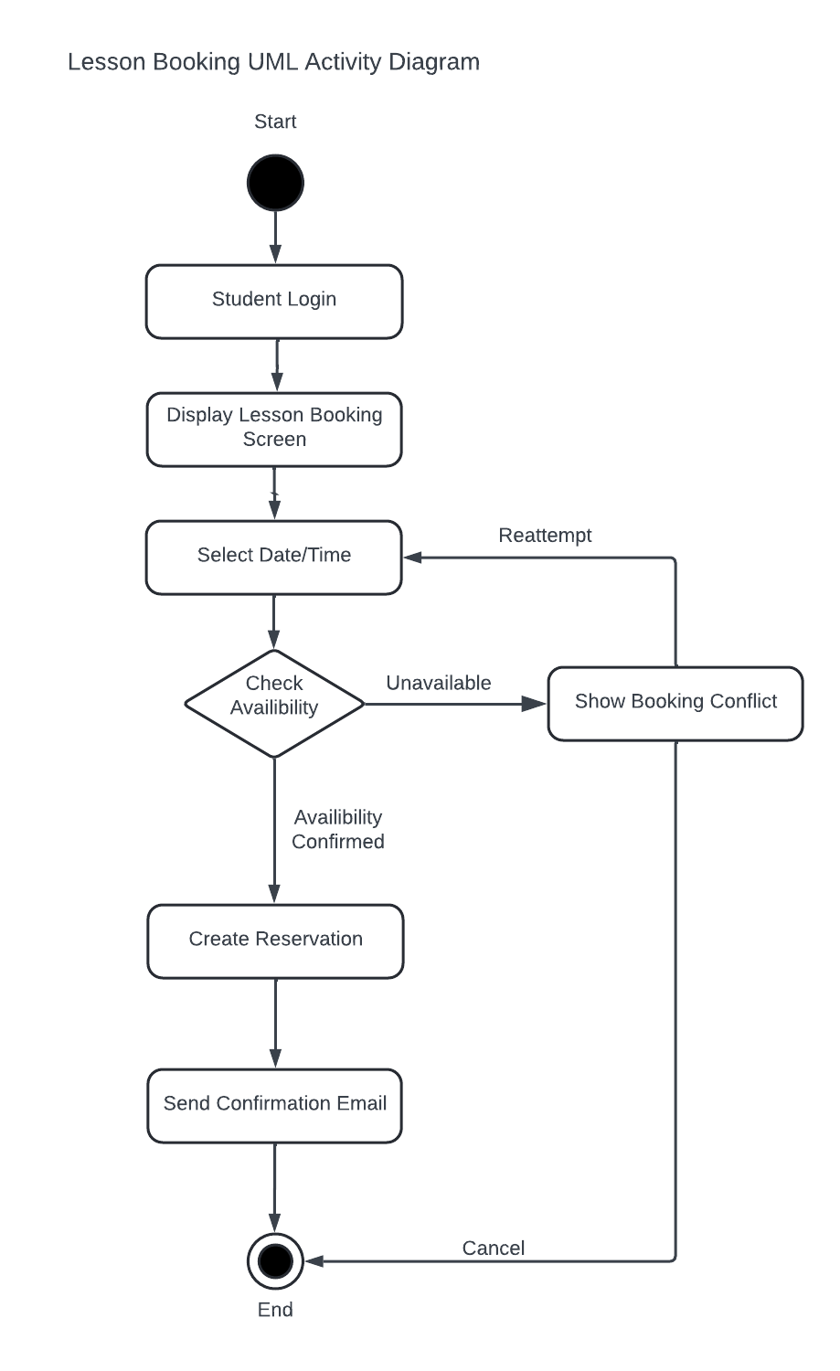

### UML Sequence Diagram

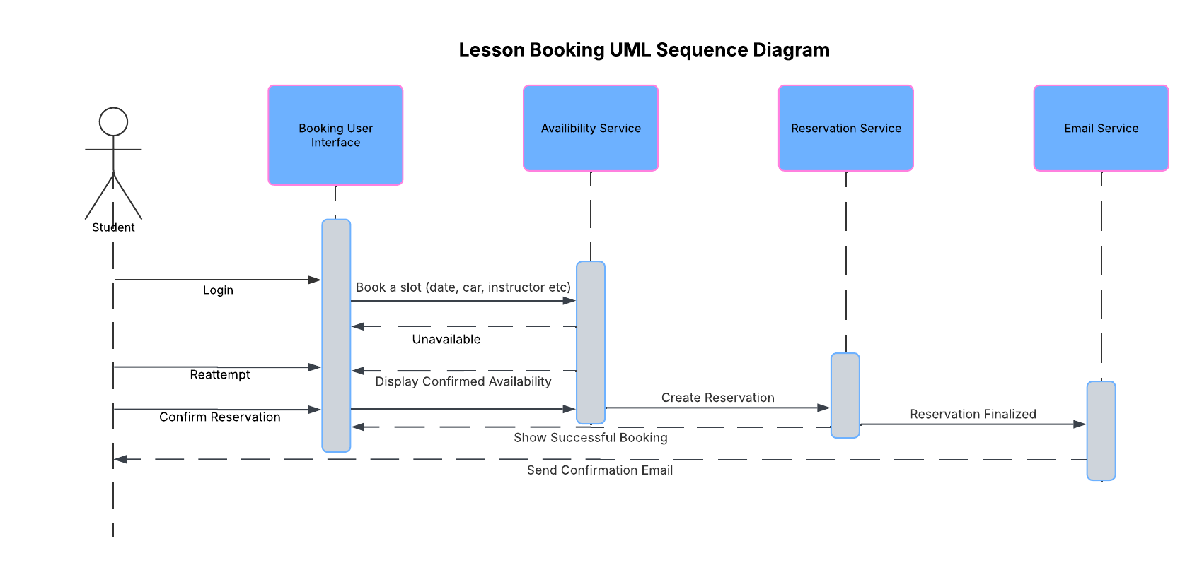

### UML Class Diagram

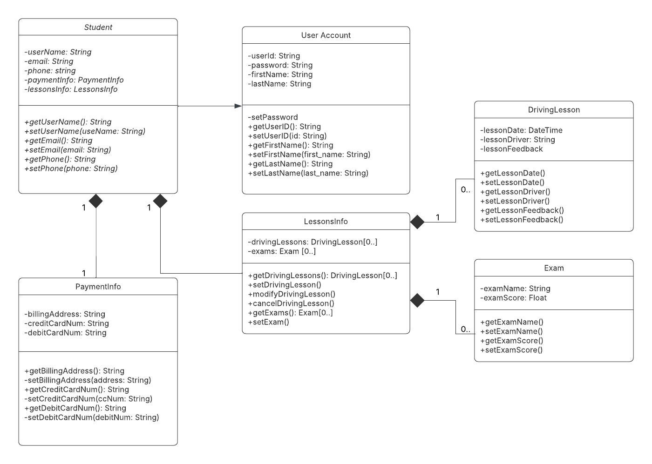

## Technical Requirements

*At least three small servers (or cloud instances) are needed. One to host the web and booking application, one to run the database, and either a third for sending emails or simply use an email service. Each instance can be modest, with the capability to add more capacity if student traffic spikes.*

*On the software side, a web framework (Node.JS/Python/Django etc) to store student profiles, lesson slots, and reservations. Keeping the code in a Git repository with automated builds and tests to catch errors before they hit production.*

*Host everything on a cloud platform to simplify scaling and management. Apply firewall rules, and schedule nightly backups of the database. Add health checks and monitoring systems so that the appropriate parties can be alerted if any service goes down.*